How to generate Javadoc with Eclipse

1. Before generating the Javadoc we need to add the corresponding Javadoc comments in the source code of our eclipse project. An example of Javadoc comments is shown below:

/**

* <h1>ItemManager</h1>

* Responsible for handling all

* the functionality needed for the items.

*

* **@version** 1.0

* **@since** 2017-07-17

*/

**public** **class** ItemManager {

**private** ArrayList<Item> allItems;

**public** ItemManager(){

allItems = **new** ArrayList<Item>();

}

/**

* Adds an item in the list

*/

**public** **void** addItem(Item anItem){

allItems.add(anItem);

}

/**

* Removes an item from the list

*/

**public** **void** removeItem(**int** index){

**this**.allItems.remove(index);

}

/**

* Retrieves an item from a selected position

*

* **@param** index: position of the item to be retrieved

* **@return** an item from the list

*/

**public** Item getItem(**int** index){

**return** **this**.allItems.get(index);

}

}

Observe how we describe the class, the methods and the method parameters. For more advice, visit Oracle:

http://www.oracle.com/technetwork/java/javase/documentation/index-137868.html

1. When in Eclipse: at the menu, follow Project -> Generate Javadoc
2. You need to complete the "Javadoc command" field - browse to find javadoc.exe

*You need to have installed* ***jdk*** *and NOT just the* ***jre.*** *Then, you can find the javadoc.exe in your < jdk_HOME_folder>\bin\javadoc.exe*

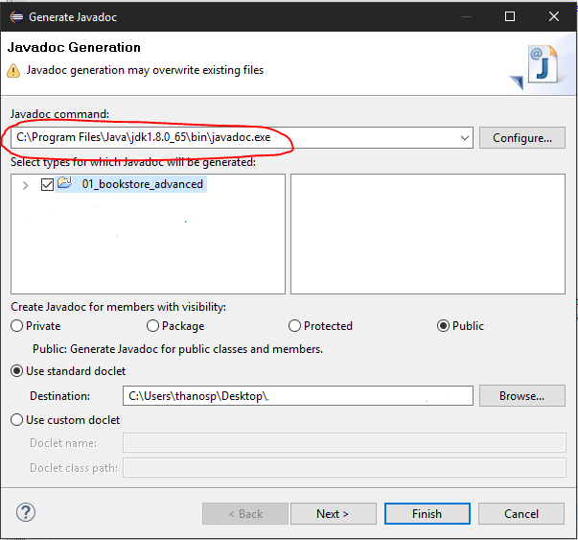

1. Select the project for which the Javadoc will be created

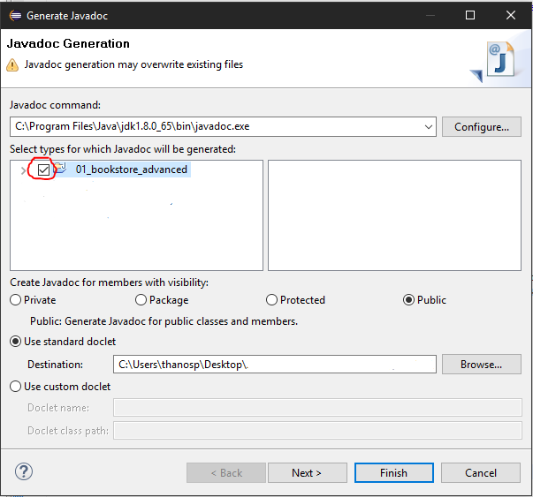

1. Specify the folder that will host the result of the generation at the “Destination” field.

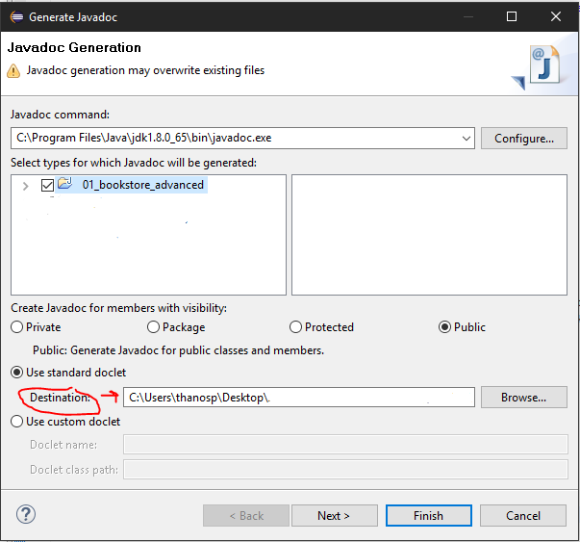

1. Click "Finish"

The result of the Javadoc generation will be a set of HTML files, stored in the destination folder. Probably, Eclipse will automatically open it for you within its environment.

In any case index.html in the destination folder is the starting page.